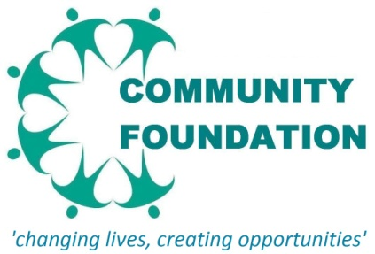
VACANCY

WOULD YOU LIKE TO EARN AND GET NVQ LEVEL 2/3 QUALIFICATION AT THE SAME TIME?

Job Title: Admin Assistant (Apprenticeship) Salary: £97.50 per week net
Location: Community Foundation 2nd floor BMDC, 148 Berners Street, Lozells B192DR
Duration: Temporary contract ends 31 March 2013
Holiday entitlement: 25 days per annum + public holidays

Hours of Work: 37.5 hours per week
Qualifications: GCSE grade A-C in Maths, English & IT or equivalent grades
Age: 16-18 years old

Closing Date for Applications: 6pm Friday 10 February 2012. Please email you CV to: cdtfoundation@aol.com

Employer
Community Foundation is a grassroots voluntary organisation supporting people, in particular the BME and Muslim community, to improve their conditions and creating opportunities for people to reach their full potential. Our core work streams are:
- develop targeted provisions for young people
- encourage civic participation, engagement and volunteering of marginalised communities.
- establish community cohesion and tolerance between communities
- promote healthy living through advice, information and encouragement to become active and live healthy
- provide education and training to up skill people who have not benefitted from mainstream education

Further info about us can be found on our web wite: www.communityfoundation.yolasite.com. Contact Nozmul Hussain 0121 370 6133 / 0782 893 1050 to discuss this vacancy.

Vacancy Description
This is an excellent opportunity to be part of a new community organisation. We are looking for an enthusiastic person eager to learn and help. This is a full time apprenticeship job for an Admin Assistant. The role includes:
- General administrative and clerical support
- Deal with telephone queries, take messages, screen and direct calls
- Deal with queries from the public and organisations in a pleasant and professional manner
- Typing and processing letters/emails & invoice
- Filing documents and updating files manually and electronically
- Maintain diary & schedule appointments
- Organising room booking
- Receive and sort mail and deliveries
- to assist in the preparation/revision of internal paperwork/reports

Training to be provided:
City & Guilds full framework Level 2/3 qualification including Key Skills Numeracy and Literacy

Skills Required
You need to be a dynamic and enthusiastic worker who enjoys the challenges of working in a team environment. The successful candidate will show that they have excellent organisational and communication skills, the ability to prioritise, good listening skills, knowledge of IT Applications, excellent time keeping and punctuality and be smartly dressed.

Future Prospects:
To go on to NVQ Level 3 Business Administration or full time paid employment

